**Week 5: Prototype Development**

1. **Initial Implementation of Core Functionalities:**

**1.1. User Signup:**

* Allows new users to create an account using Firebase Authentication.
* Input validation ensures all fields are filled and passwords match.
* A verification email is sent after account creation.

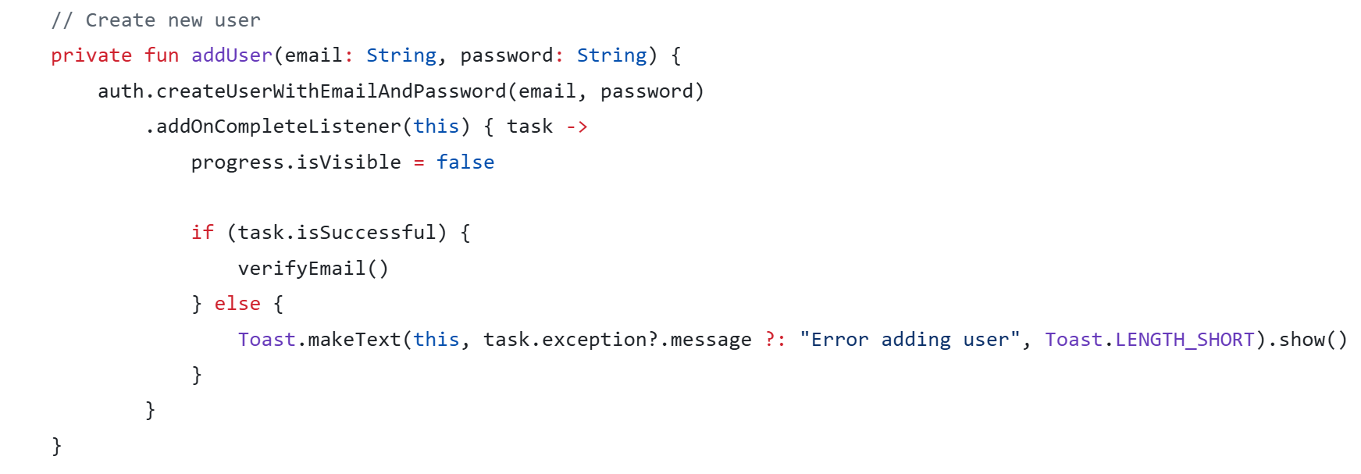

#### **1.2. User Login:**

* Authenticates existing users through Firebase.
* Verifies if the user's email is confirmed before proceeding.
* 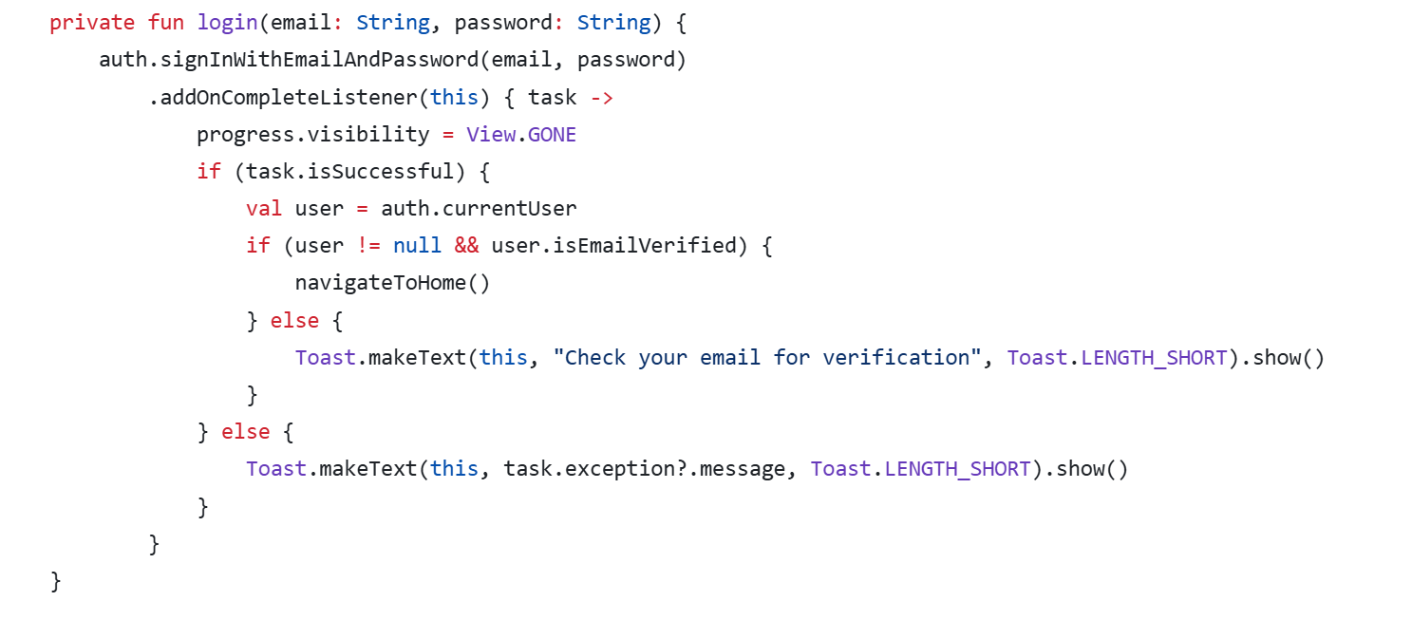Allows password reset functionality.

1. **Key Design Patterns Implemented:**

**Factory Pattern:**

The AccountFactory class implements the **Factory Design Pattern** to abstract the instantiation of different types of accounts (e.g., User, Company). This design allows the system to create specific account objects based on input type, enabling scalability and loose coupling between client code and concrete implementations.

